To

The Public Information Officer

National Informatics Centre

Kolkata

Subject: - Information needed under RTI Act 2005

Sir / Madam,

With reference to the above mentioned subject, I would like to draw your kind attention towards the matter that I need below mentioned information regarding a person with below details.

**Details of person for whom information is required: -**

Name: - Archana Kumari (alias - Archana Kumari Sah)

Aadhar Number: - 9815 4391 2842

D/O: - Umesh Nandan Prasad

W/O: - Vijay Kumar Sah

**Information needed: -**

1. If the above person is doing job as COPA (Computer Operator and Programming Assistant) in National Informatics Centre, Kolkata or at any other designation
2. If yes, then what is the designation of the person
3. If yes, then what is the monthly salary of the person
4. If not, then what is the reason for this person to carry out authentication using fingerprint at a device deployed at National Informatics Centre (Kolkata) on regular basis

I, therefore, request your kind attention to please provide me with the above details at the earliest. Thanking you.

**Yours sincerely,**

Vijay Kumar Sah

57/2B, Bondel Road,

P.O- Ballygunge,

Kolkata – 700019

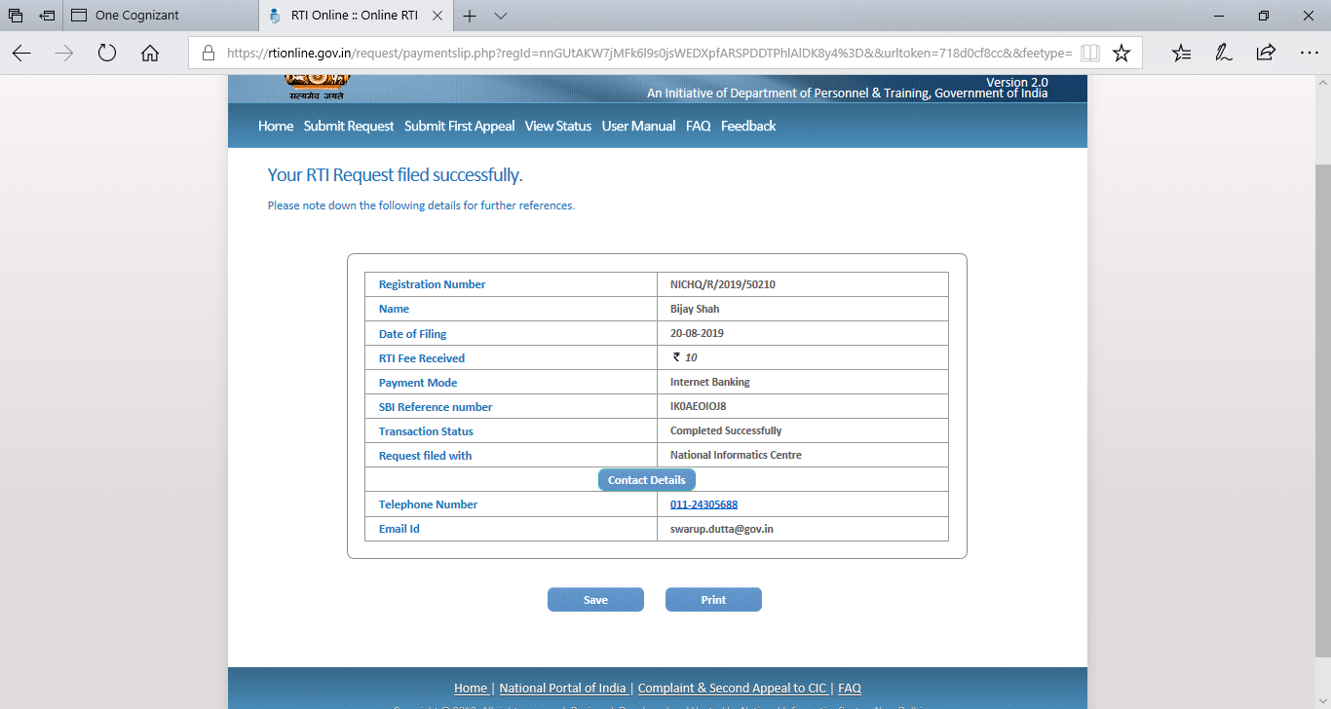

<URL:-> https://rtionline.gov.in/request/savepdf.php?regId=nnGUtAKW7jMFk6l9s0jsWEDXpfARSPDDTPhlAlDK8y4%3D